Time:



------------------------------------------------------------------

Identity Matrix:

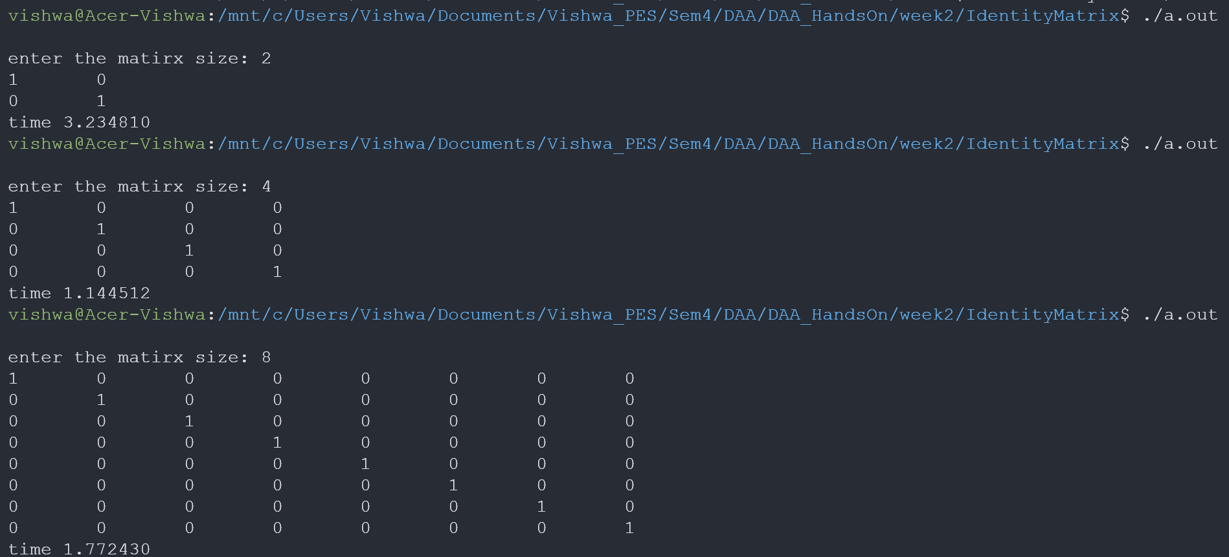

------------------------------------------------------------------

Random Matrix:

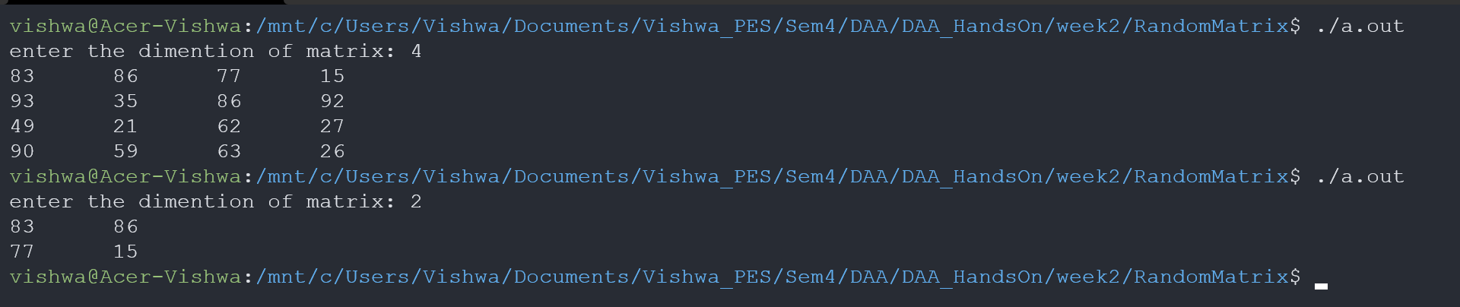

------------------------------------------------------------------

Matrix Addition:

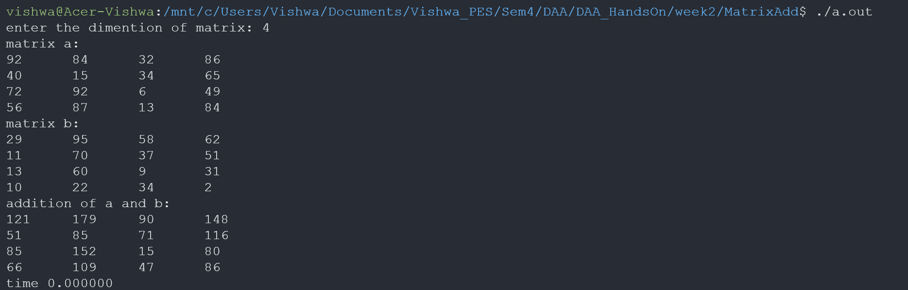

------------------------------------------------------------------

Matrix Multiplication:



